1.Total number of patients
select count(case_id) as total_patients
from train_data td ;

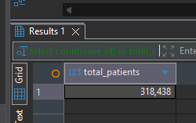

2.Total number of hospital
select count(distinct hospital_code) as Total_hospitals
from train_data td;
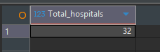

3.Average admission deposit
select Avg(admission_deposit) as avg_deposit
from train_data td;
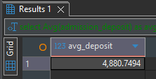

4.Average patient visitors
select Avg(`Visitors with Patient`) as
avg_visitor
from train_data td;
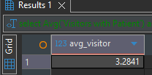

5.Patients by admission type
select `Type of Admission`,count(*) as total_cases
from train_data
group by `Type of Admission` ;
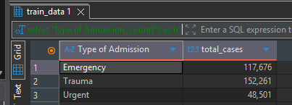

6.Patientsby severity level
select `severity of illness`,count(*) as total_cases
from train_data
group by `severity of illness`
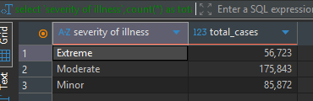

7.Patients by department
select department,count(*)as patient_count
from train_data
group by department
order by patient_count desc;
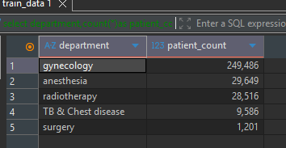

8.Top 10 most cities with most patients
select city_code_patient,count(*) as patient_count
from train_data
group by city_code_patient
order by patient_count desc
limit 10;
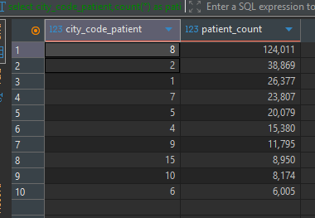

9.Patients by age group
select age,count(*)as total_patients
from train_data
group by age
order by total_patients desc;
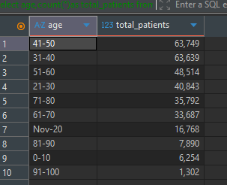

10.Average deposit by severity
select `severity of illness`,
Round(avg(`admission_deposit`),2) as avg_deposit
from train_data
group by `severity of illness`;
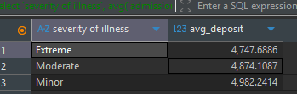

11. Average deposit by department
select department,avg(admission_deposit)as avg_deposit
from train_data
group by department
order by avg_deposit desc;
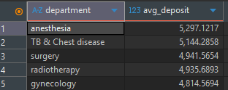

12.Patients by Hospital
select hospital_code,count(*)as total_patients
from train_data
group by hospital_code
order by total_patients desc;
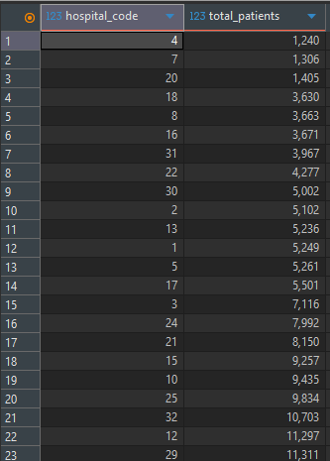


13.Average visitors by severity
select `severity of illness`,avg(`visitors with patient`) avg_visitors
from train_data
group by `severity of illness` ;
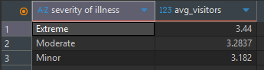

14.Admission deposit by age group
select age,avg(admission_deposit)as avg_deposit
from train_data
group by age;
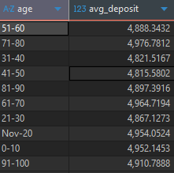

15.Patients by bed grade
select `Bed grade`,count(*)as total_patients
from train_data
group by `bed grade`;
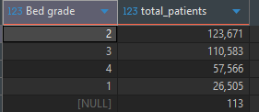

16.Patients with highest deposit
select patientid, admission_deposit
from train_data
order by admission_deposit desc
limit 10;
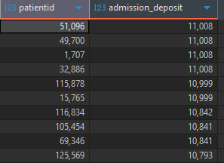

17.Patients with most visitors
select patientid,`visitors with patient`
from train_data
order by `visitors with patient` desc
limit 10;
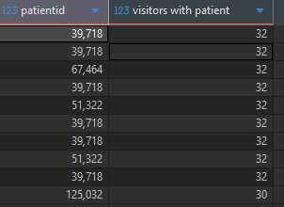

18.Average stay by severity
select `severity of illness`,round(avg(stay),2)as avg_stays
from train_data
group by `severity of illness` ;
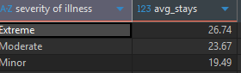

19.Admission type vs average deposit
select `type of admission`,avg(admission_deposit)as avg_deposit
from train_data
group by `type of admission`;
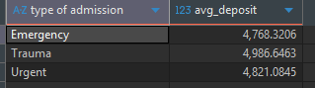

20.Department with highest deposit
select department,Max(admission_deposit)as highest_deposit
from train_data
group by department
order by highest_deposit desc;
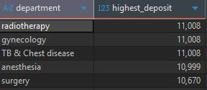

21.Rank hospital by patient count
select hospital_code,
count(*) as patient_code,
Rank() over (order by count(*) desc) as hospital_rank
from train_data
group by hospital_code;
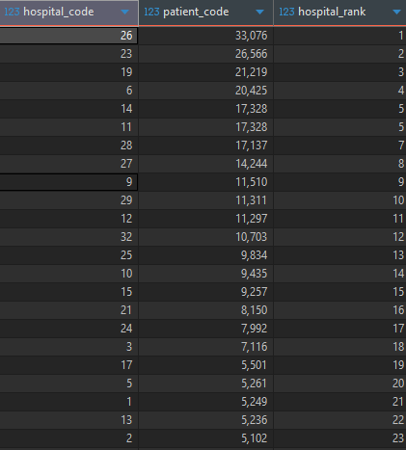
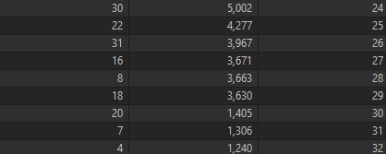
22.Top 5 department with highest patients
select department,count(*)as total_patients
from train_data
group by department
order by total_patients desc
limit 5;
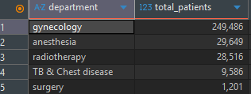

23.Running total of patients by hospital
select hospital_code,
count(*) as patients,
sum(count(*))over(order by hospital_code) as running_total
from train_data
group by hospital_code;



24.Rank cities by patient count

select city_code_patient,
count(*)as patient_count,
dense_rank() over (order by count(*) desc)as city_rank
from train_data
group by city_code_patient;
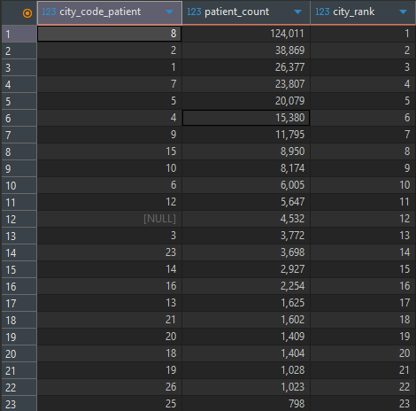

25.Percen% of patients by severity
select `severity of illness`,
round(count(*)*100.0/(select count(*)from train_data),2) as percentage
from train_datagroup by `severity of illness` ; 